Data Communication and Network
LAB

FAROOQ AHMAD Experiment #13
17L4407 Lab Report # 12
BEE-5A

INTRODUCTION TO SOCKET PROGRAMMING

INTRODUCTION
In this lab session, we were introduced socket programming. Socket programming is a way of connecting two nodes on a network to communicate with each other. One socket (node) listens on a particular port at an IP, while other socket reaches out to the other to form a connection. A socket is defined as an endpoint for communication. A pair of processes communicating over a network employs a pair of sockets—one for each process. A socket is bound to a port and an IP address, via which information can be sent and received. Moreover, in a client-server model, socket programming is extremely important, as it ensures communication between the client and server.

OBJECTIVE

The course learning objective of this lab session was to learn the commands to run the C/C++ files and learn and Understand Communication using socket programming.

DESIGN PROCEDURE
TASK#1
Procedure
1) Compile both client and server using GCC in Ubuntu terminal
2) First run the server
3) Open a new terminal window
4) Run the clients in the second terminal
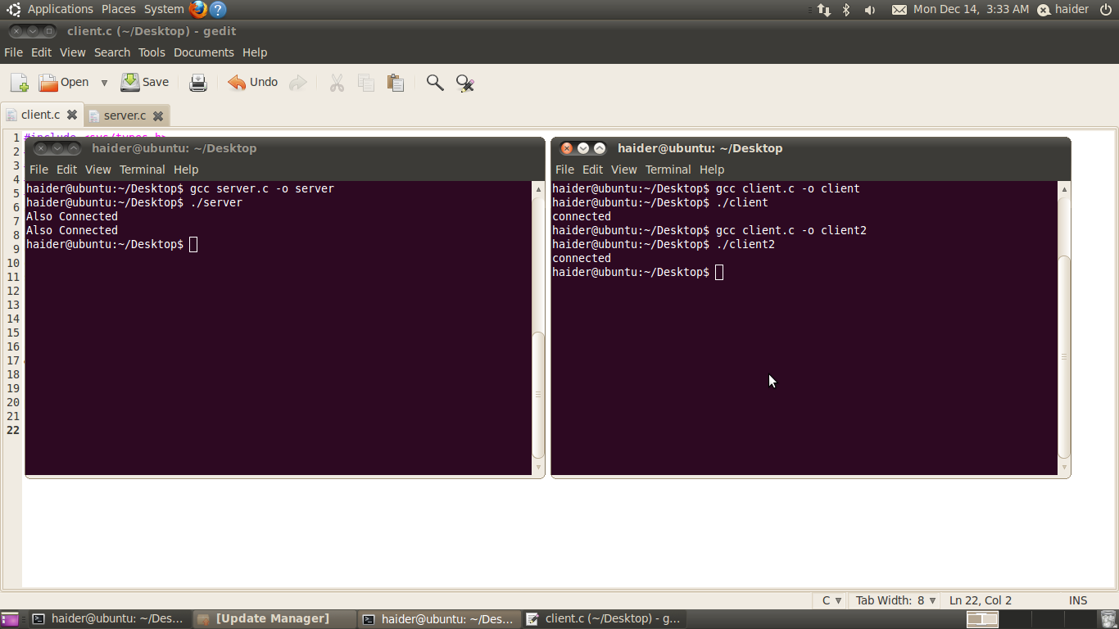
TASK#2
Modify the server and client code to make an authentication method to establish the connection with client. The client will send a username and password if both are correct the further connection will continue else the connection will stop.
SERVER CODE
#include <sys/types.h>
#include<sys/socket.h>
#include<netinet/in.h>
#include<stdio.h>
#include <unistd.h>
#include <string.h>
int main()
{
int sd;
char* msg="connected";
char* username="fehmedc";
char* password="farooq";
char msg1[100];
char msg2[100];
struct sockaddr_in my_addr, client_addr;
my_addr.sin_family=AF_INET;
my_addr.sin_port=htons(4999);
my_addr.sin_addr.s_addr=inet_addr("127.0.0.1");
sd=socket(AF_INET,SOCK_STREAM,0);
bind(sd,(struct sockaddr *) &my_addr,sizeof(struct
sockaddr_in));
listen(sd,15);

int size=sizeof(struct sockaddr);
int new_sd=accept(sd,(struct sockaddr*)&client_addr,&size);
send(new_sd, "Enter Username",100,0);
recv(new_sd,msg1,100,0);
printf("%s%s","Username is ",msg1);
send(new_sd, "Enter Password",100,0);
recv(new_sd,msg2,100,0);
printf("%s%s\n","Password is ",msg2);
if(strcmp(msg1,"username")==0 && strcmp(msg2,"password")==0)
{
send(new_sd, msg,100,0);
recv(new_sd,msg1,100,0);
printf("%s\n",msg1);
}
else
{
send(new_sd, "error",100,0);
}
return 0;
}

CLIENT CODE
#include <sys/types.h>
#include<sys/socket.h>
#include<netinet/in.h>
#include<stdio.h>
#include <unistd.h>
#include <string.h>
int main()
{
int sd,sd1;
char msg[100];
char* msg1="Also Connected";
struct sockaddr_in server_addr;
server_addr.sin_family=AF_INET;
server_addr.sin_port=htons(4999);
server_addr.sin_addr.s_addr=inet_addr("127.0.0.1");
sd=socket(AF_INET,SOCK_STREAM,0);

connect(sd,(struct sockaddr*)
&server_addr,sizeof(struct sockaddr));
recv(sd,msg,100,0);
printf("%s\n",msg);
fgets(msg, 10, stdin);
send(sd, msg,100,0);
recv(sd,msg,100,0);
printf("%s\n",msg);
fgets(msg, 10, stdin);
send(sd, msg,100,0);
recv(sd,msg,100,0);
if(strcmp(msg,"connected")==0)
{
printf("%s\n",msg);
send(sd, msg1,100,0);
}
else
{
send(sd, "error",100,0);
}
return 0;
}

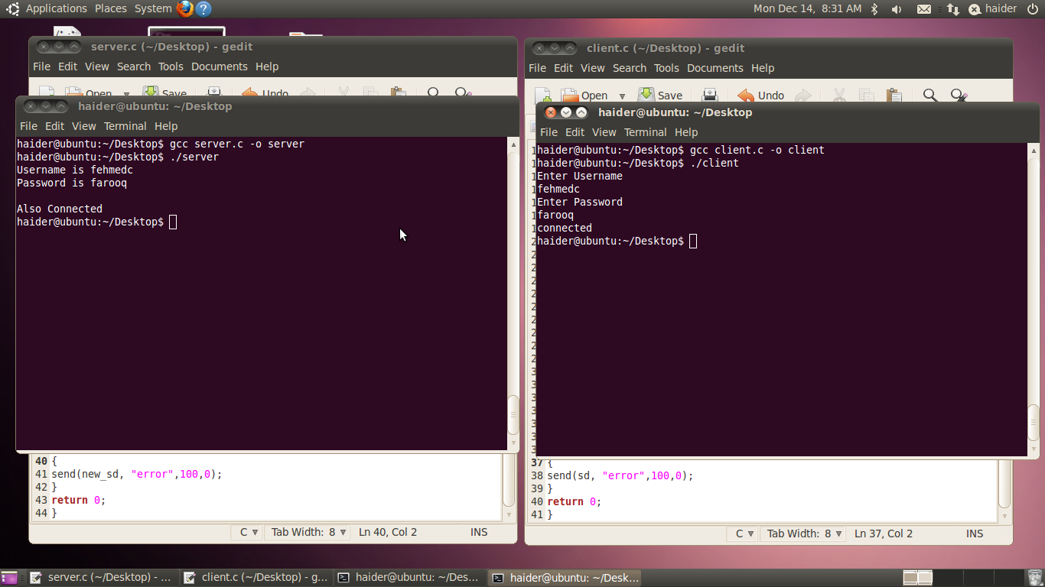

ISSUES
There were various issues while doing the multiple communication between the server and client.

CONCLUSION
This lab session was conducted successfully. From this experiment activity, we learned how to program sockets and make communication possible between two parties. Basically, a socket helps us to establish a connection between a server and client, by using the assigned port and IP address. Communication is made possible when the client requests a server and the server responds to its request and gives the client some sort of service. At this point, sockets are important because they ensure that end-to-end communication is possible.

APPLICATIONS
Socket programming is used for developing client-server applications in Java. In client-server architecture, the server provides some service and the client can use this service to get the desired output or result. Sockets also allow two or more computers to communicate with each other over the network using TCP/IP protocol. Socket programming is an integral part of data communication systems, as it allows us to configure different type of services over ports. Some of the standard services offered via server are FTP, SMTP, HTTP/HTTPS etc. These protocols are implement using socket programming and port binding.

